Correction of Ball Grid Array Shape on Printed Circuit Board (PCB)

1*Rohit Das,*2*Chiou-Shann Fuh* (傅楸善)

1Department of Computer Science and Information Engineering,

National Taiwan Normal University, Taipei, Taiwan,

2Department of Computer Science and Information Engineering,

National Taiwan University, Taipei, Taiwan

E-mail: [rdas.879@gmail.com](mailto:rdas.879@gmail.com) , [fuh@csie.ntu.edu.tw](mailto:fuh@csie.ntu.edu.tw)

#### Abstract

In our project, we attempt to reconstruct 3D solder balls on the PCB (Printed Circuit Board) according to 128 projections of X-ray images of those solder balls. We mainly use different image reconstruction techniques from sinogram and fix the shape of the solder balls.

**Keywords:** Solder Balls; 2D Reconstruction;

ART; MART; SART; FBP

**1. Introduction**

Manufacturers of PCB (Printed Circuit Board) need to ensure the quality of their products. Therefore, it is necessary for them to have an effective method to inspect their product in order to find out if there are any defects. For example, there may be some cracks or voids in the solder ball, which cannot be seen easily in visible light. However, if we can get the X-ray image of solder balls, we can find the cracks in it. Furthermore, 2D image contains more information and can be easy to understand. After realizing the significance of this research, we have tried different methods to reconstruct the image of solder balls. We also use laminography to reconstruct the cross-section image on the focal plane of our X-ray system. Further, in order to get a more accurate 3D model, we create an original method which can provide us with a more accurate result. This method can benefit the inspection industry especially the ones focused on finding the quality of PCB

**2. SYSTEM SETUP**

Reconstruction plays a vital role in inspection because the better result of the reconstruction, the more effective we inspect the defects. The structure in our projection system[1] is illustrated as follows: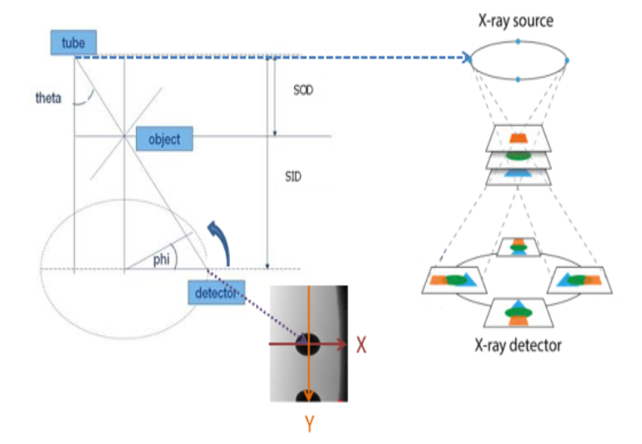Figure 1: System setup Theta (35) is the angle between tube to detector and vertical line. SOD (Source to Object Distance) = 18.432mm. SID (Source to Image Distance) = 201.541mm, and phi is the angle of rotation.

Image Dimension = 1,496 1,496 pixels,4m/pixel

By the relative motion between X-ray source and detector, the system can obtain an image including tilt object after rotating phi degrees (=)

When the source and detector complete 360 rotation, we can use those images to implement our reconstruction.

**3. ART (Algebraic Reconstruction technique)**

**3.1. ART (Algebraic Reconstruction Technique)**

In the field of Computed Tomography, ART (Algebraic Reconstruction Technique) is widely used to reconstruct the cross-section of an object. It is an iterative method and can gradually reconstruct the image based on projections of that image in different angles.

The iterative algorithm [2] is defined as,

= 1,2,3…M = 1,2,3…. N

: total number of projection rays.

: total number of pixels.

: relaxation factor.

: the projection value of the -th ray.

: the weight of the -th pixel on the -th ray.

: the -th pixel value after being updated by the -th ray

: the current projection value of the i-th ray.

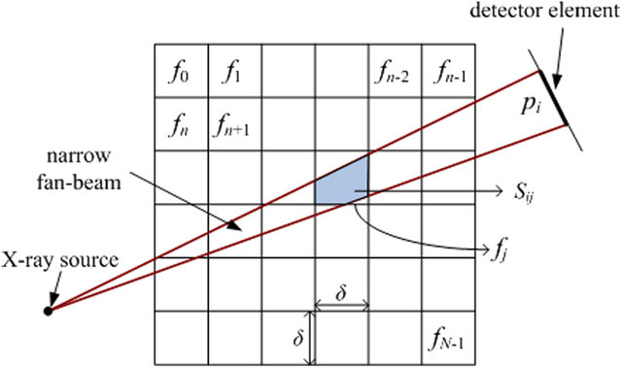

Figure 2:  Area integral model of Algebraic Reconstruction Technique (ART) in the fan-beam geometry.

**3.2. Reconstruct 2D image by ART**



Figure 3: Test image. Many shapes are needed to be reconstructed

First, we need to obtain projections in different angles used to reconstruct the image. We generate projections of this image from 0 to 179 , 1 for each projection and we put them together in one image.

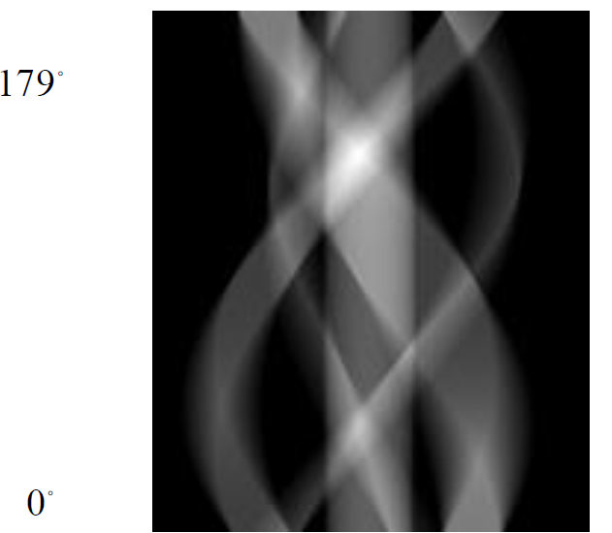

Figure 4: Projections of the image. Every row of this figure is one projection of a certain angle of that angle (1 degree/projection).

According to the principles of ART, we revised a C++ program of ART and successfully reconstruct the original image.



Figure 5: Above image shows results after increasing number of iterations to 100 with relaxation factor 4.

The experiment shows that though reconstructed, the image still has some halo effect which even after post processing was very hard to remove.

**4. SART (Simultaneous Algebraic Reconstruction Technique)**

SART is another popular method in the field of computed tomography. Moreover, SART considers all projection rays in one iteration to reconstruct the image, unlike that ART only uses one ray to reconstruct the image in one iteration. Generally, SART is believed to resist severe noise and can guarantee a better quality of the reconstructed image than ART.

Therefore, based on this formula, in one iteration, SART takes all rays into consideration, thus after one iteration, image will mostly appear. We take Figure 3 as an example and attempt to reconstruct it. Successfully, we get the result after just one iteration.

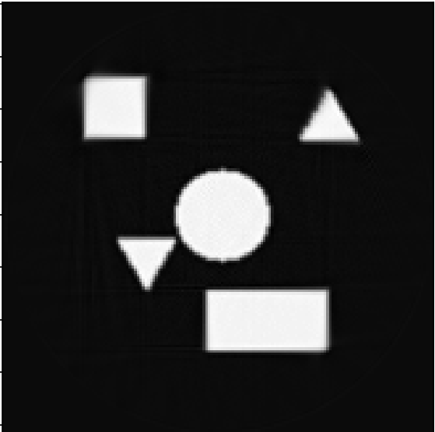

Figure 6: Reconstructed image after using SART. The image shapes are much more prominent and very less halo effect compared with ART.

**6. 3D Reconstruction by SART**

3D Reconstruction is based on the knowledge of 2D reconstruction by SART. We can reconstruct the 3D object layer by layer. Moreover, the reconstruction of just one layer is the same as what we do in 2D reconstruction. After all layers are reconstructed, we stack them together to obtain the 3D object.

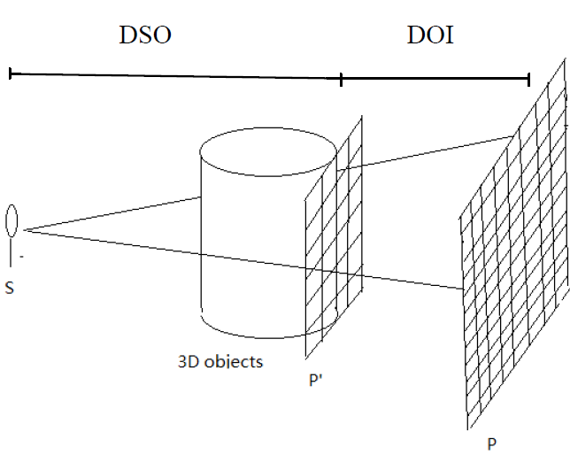

Figure 7: The way we get projections [1]. DSO: Distance between source and object. DOI: Distance between object and image.

In Figure 7, we get the projection of the 3D object efficiently. First, we reduce the physical size of image but maintain its size in pixels to fit image in physical size. Second, because images and have different pixels and we can easily get image , which is the parallel projection of the 3D object, so we use image to interpolate image . Therefore, we obtain image which is the actual projection in that system.

As for the process of 3D reconstruction, we just conduct a reverse operation. We use image to interpolate image . After acquiring in different angles, we can use SART to reconstruct the 3D object layer by layer.

Figure 8 shows objects which we want to reconstruct [1]. Figure 8 (a) corresponds to image *P’* in Figure 7.

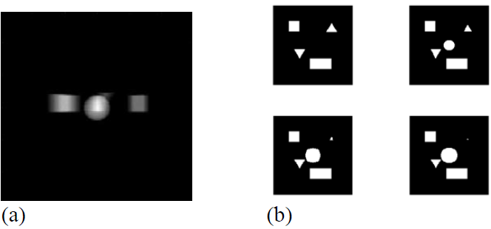

Figure 8 (a) 3D objects we want to reconstruct, including a cube, a sphere, a cuboid, a triangular pyramid and a triangular prism. (b) Cross-sections of those objects obtained at different heights.

We take reference from a program written by Kyungsung Kim [2] and revise it to fit our test case. Below is the result after 3D reconstruction.

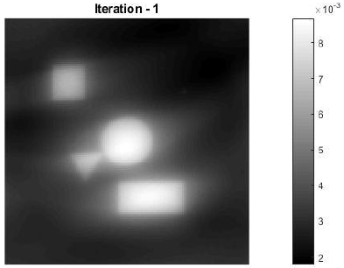

Figure 9 A cross-section of the reconstructed 3D object (after one SART iteration) at the height of 15 pixels.

7. EVALUATION

Applying the SART algorithm on BGA images provided by TRI [4], below are the results:

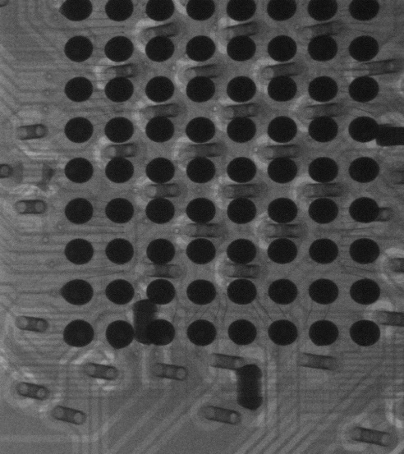

Figure 10 An X-Ray image of Ball Grid projected at 16

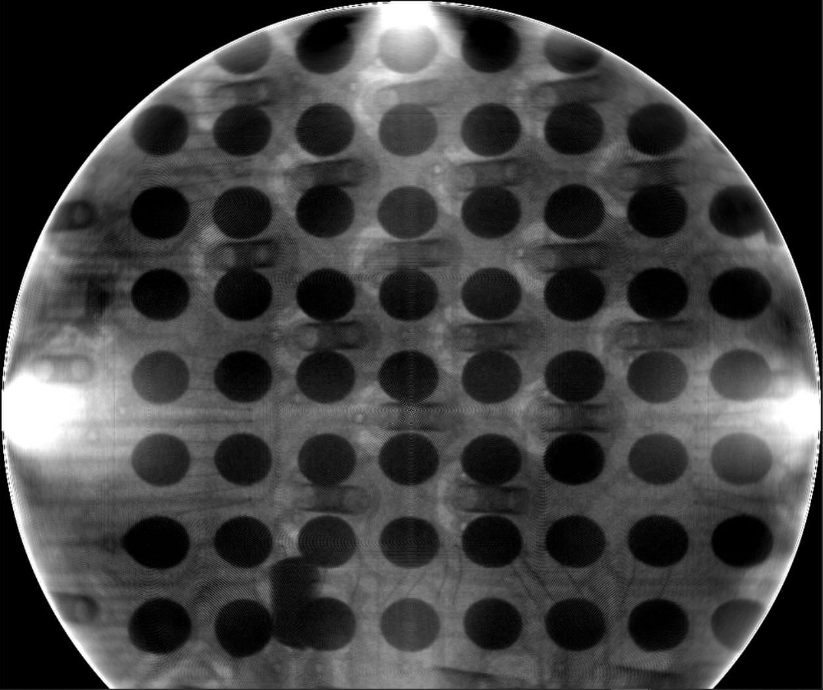

Figure 11 Reconstruction of the above image using SART at 1 iteration

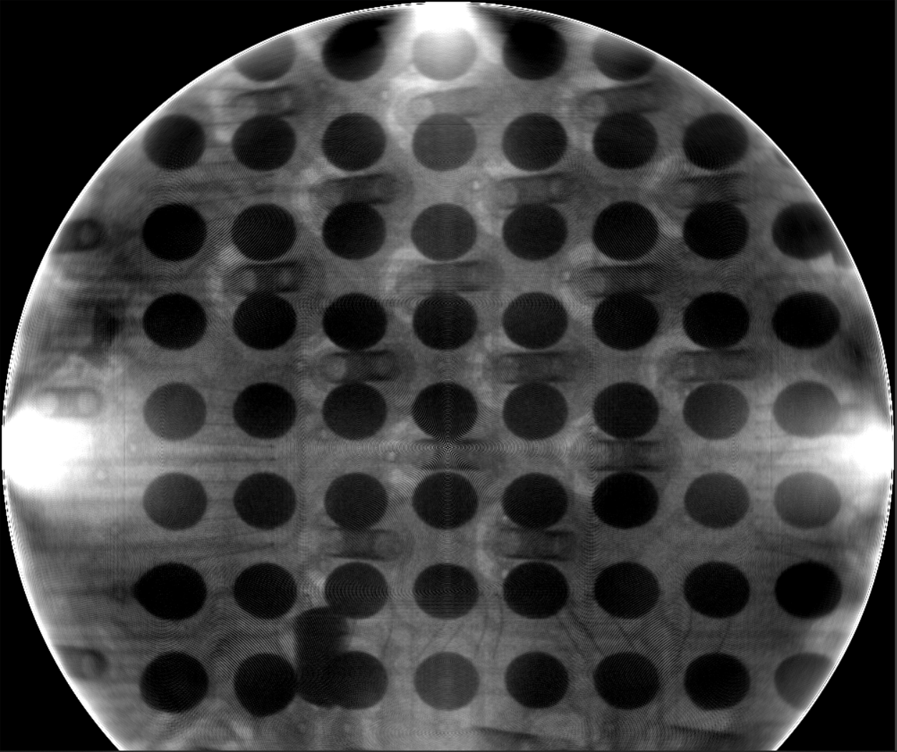

Figure 12 Reconstruction of the above image using SART at 2 iteration

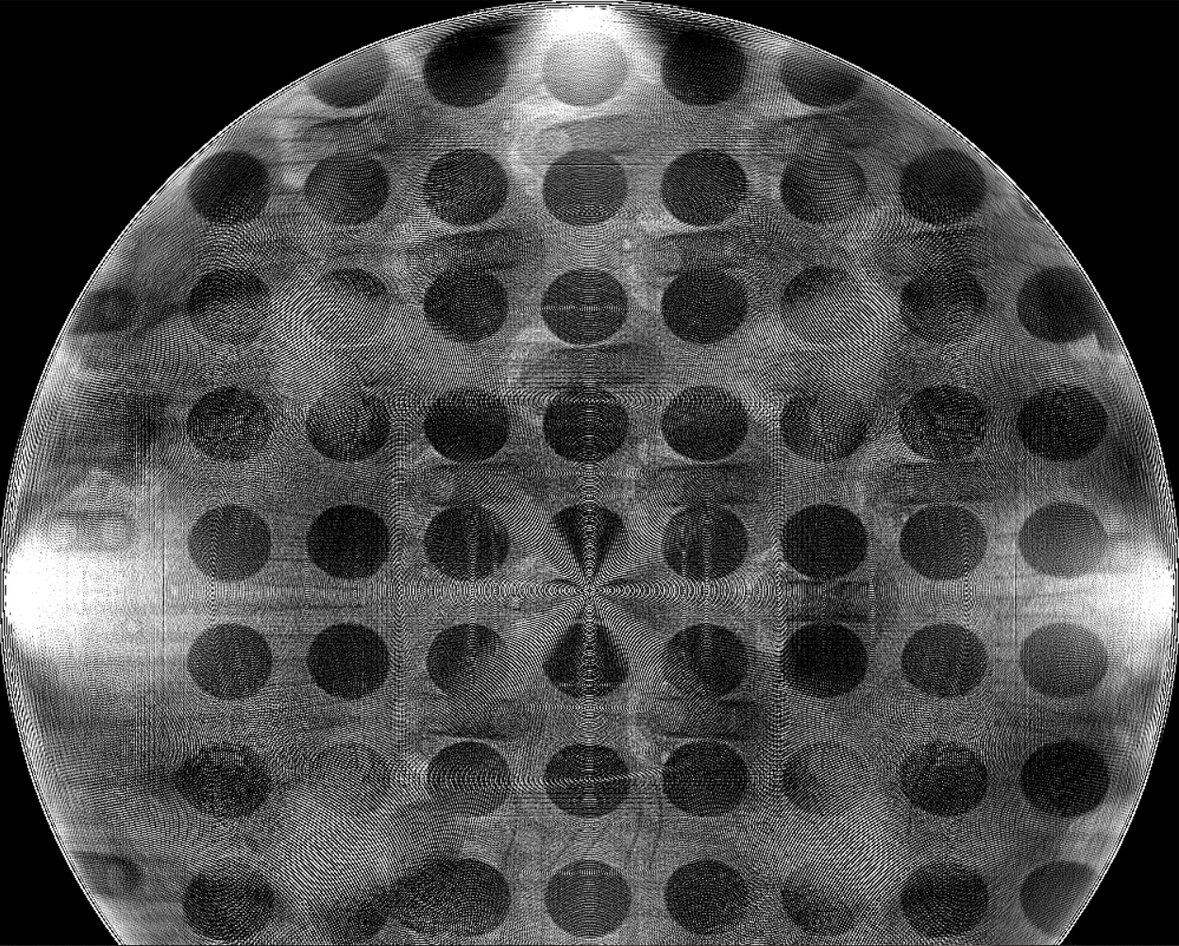

Figure 13 Reconstruction of the above image using SART at 2 iteration and applying a sharpen filter

As we can see from the above images though the reconstruction is quite commendable, we lose much data at the corner. Also, the reconstruction takes a lot of computation time. The above images are all 2D images which are not normalized.

After normalization and applying 3D reconstruction, we get the following results.

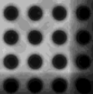

Figure 14 3D Reconstruction of the solder ball after layering each image one after another.

Though we get the 3D data, we are losing a lot of information at the corners.

8. Conclusion

This paper gives a brief evaluation of different reconstruction techniques used from sinogram. Out of the various techniques used, we found SART technique to be most promising. We also saw how 3D reconstruction works. The result of SART though looks promising, needs much research to get the desired shape and information we are looking for.

**9. References**

1. Y. B. Zhang,“3D Reconstruction of Solder balls,” Department of Electronic Science and Engineering, Nanjing University, Nanjing, China, 2016.
2. H. K. Lin, “Algebraic Reconstruction Technique,” Technical Report, Department of Computer Science and Information Engineering, National Taiwan University, 2016.
3. K. S. Kim, “3D Cone Beam CT (CBCT) Projection Backprojection FDK, Iterative Reconstruction Matlab Examples” ,2022.
4. Test Research Inc.Taipei,Taiwan.

<https://www.tri.com.tw/en/index.html>